*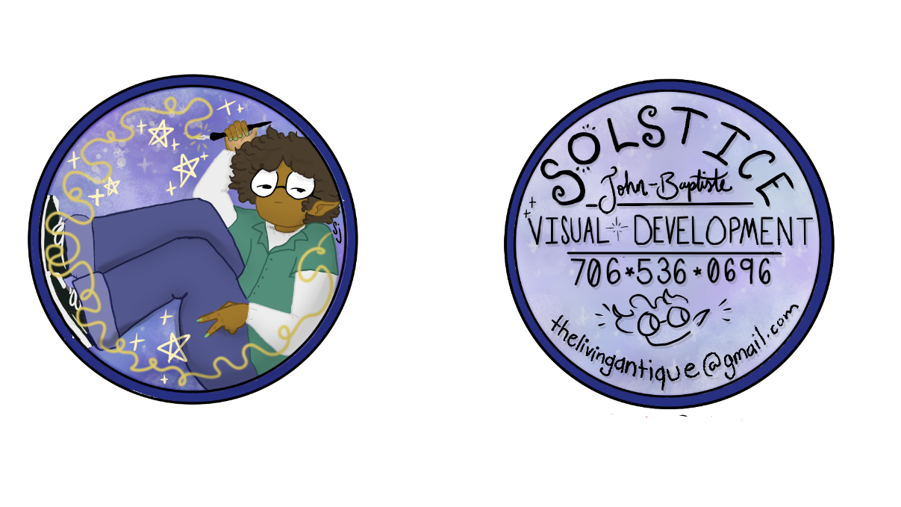*Solstice John-Baptiste



*Visual Developer*



✉: [thelivingantique@gmail.com](mailto:thelivingantique@gmail.com)  ☏: 706-536-0696

*Software*

☾ *Toonboom (Harmony & Storyboard Pro)*

☾ *Adobe Premiere Pro*

☾ *Adobe Photoshop*

☾ *Microsoft Office*

☾ *FireAlpaca*

*Skills*

*☾* *Storyboarding*

☾ *Screenwriting + Scripting*

☾*Film Direction and Production*

☾ *Collage*

☾ *2D Animation*

☾*Character Design*

☾*Environment Design*

☾*Prop Design*

☾*Compositing*

*Soft Skills*

☾ *Effective Communication*

☾ *Flexible*

*☾ Collaborative*

*☾ Risk-taking*

*☾ Assertive*

*Artist’s Biography*

*Enthusiastic and dedicated visual developer that specializes in creating dynamic characters, environments, and props. Strongest work is conveyed in traditional and hand-drawn works. Able to be flexible and go with the flow of intense projects.*

*Education*

*Animation Story + Concept Major at the Savannah College of Art and Design, BFA (2022 – 2026).*

*Work Experience*

*Model at Colorblast Makeover Studio (2018-2023)*

Engaged with customers and convention attendees, provided customers information on cosmetic products being sold Modelled the business’ cosmetic line and clothing .

*Business Owner under livingantique (2020-present)*

Hand-crafted accessories, stickers, and tote bags, engaged with clients and assisted them in choosing styles + merchandise, designed logos, business cards and advertisement fliers.

*Customer Service Associate at Walgreens (2024)*

Assisted customers with their shopping needs + purchase, cleaned major areas on store floor, answered phone calls, restocked shelving.

*Producer on* “The Presence Within” (March 2025)

Provided schedule, time management assistance, general advising and script assistance for a student short film.

*Customer Associate at Hot Topic (June – September 2025)*

Assisted customers in purchasing items, choosing their styles, and finding merchandise. Also assisted in restocking shelves and accounting for new stock.

*Game Host at Escapology (June – September 2025)*

Assisted customers in understanding the ins and outs of participating in an escape room. Also assisted in mastering games, offering clues, taking photos and booking future clients.